Algorithms and Flowcharts

1. Fundamental Concepts & Easy Definitions
Algorithm
Definition: A step-by-step solution to any problem, written in pseudocode or plain English along with spoken language.
Core Characteristics:
• Sequential: Clear start-to-finish order.
• Unambiguous: Each instruction is clear.
• Finiteness: Must terminate after a finite number of steps.
• Input/Output: Takes inputs and produces defined outputs.

Flowchart
Definition: The symbolic (visual) representation of an algorithm showing the flow of the process.
Why Flowcharts Matter:
• Visual Clarity: Easier to grasp complex logic at a glance compared to long text.
• Debugging: Helps spot logical dead-ends or infinite loops easily.
• Direct Mapping: Shapes map directly to C control statements (if-else, while).

2. Standard Flowchart Symbols & C Mapping
Recognize these universal standard visual symbols and how each translates to C code:
Symbol Name | Visual Shape | Purpose & Function | Screenshot
Start / Stop | Oval / Stadium | Marks the entry and exit points of the algorithm program flow. | 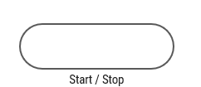
Input / Output | Parallelogram | Represents reading user inputs or displaying results on screen. | 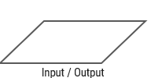
Process | Rectangle | Indicates calculations, memory assignments, or data processing. | 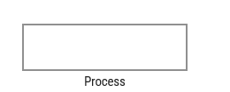
Decision Making | Diamond | Evaluates a relational condition (True/False or Yes/No) to branch execution. | 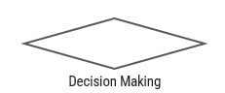
Lines | Arrows (→) | Shows the exact directional path of execution from step to step. | 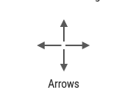
Subroutine | Predefined Rect | Represents a predefined module, function call, or external process. | 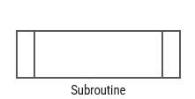

3. In-Class Examples & Blackboard Walkthroughs
Walk through these core examples step-by-step.
Example 1: Positive or Negative Number
[Algorithm]
1. Step 1: Read no.
2. Step 2: If no >= 0, go to Step 4.
3. Step 3: Print no is a negative number, go to Step 5.
4. Step 4: Print no is a positive number.
5. Step 5: Stop.

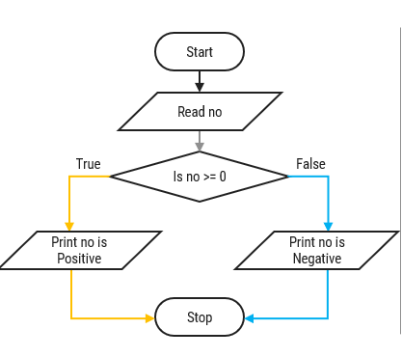

Example 2: Odd or Even Number
[Algorithm]
1. Step 1: Read no.
2. Step 2: If no mod 2 = 0, go to Step 4.
3. Step 3: Print no is odd, go to Step 5.
4. Step 4: Print no is even.
5. Step 5: Stop.

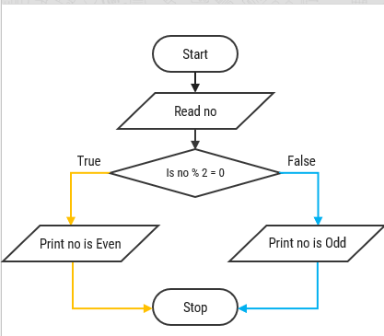

Example 3: Find Largest of 2 Numbers
[Algorithm]
Step 1: Read a, b
Step 2: If a > b,
go to Step 4
Step 3: Print b is largest
go to Step 5
Step 4: Print a is largest
Step 5: Stop.
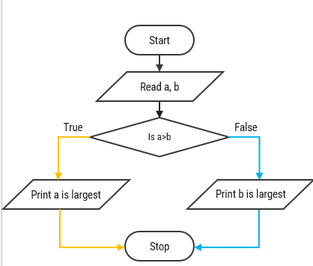

Example 4: Find Largest of 3 Numbers (Nested Logic)
[Algorithm]
1. Step 1: Read a, b, c.
2. Step 2: If a > b, go to Step 5.
3. Step 3: If b > c, go to Step 8.
4. Step 4: Print c is largest number, go to Step 9.
5. Step 5: If a > c, go to Step 7.
6. Step 6: Print c is largest number, go to Step 9.
7. Step 7: Print a is largest number, go to Step 9.
8. Step 8: Print b is largest number.
9. Step 9: Stop.

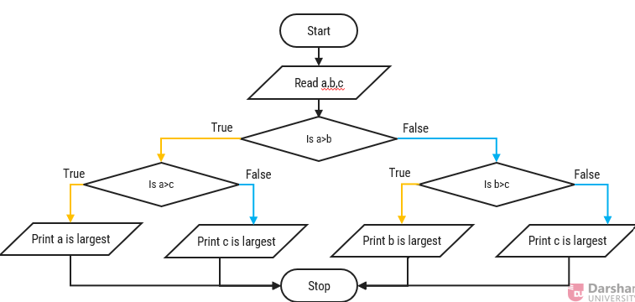

4. Advanced Control Structures: Loops, Primes & Factorials
Example 5: Looping - Print Numbers 1 to 10
[Algorithm]
Step 1: Initialize a = 1 | Step 2: Print a | Step 3: Repeat step 2 until a <= 10 (Step 3.1: a = a + 1) | Step 4: Stop.

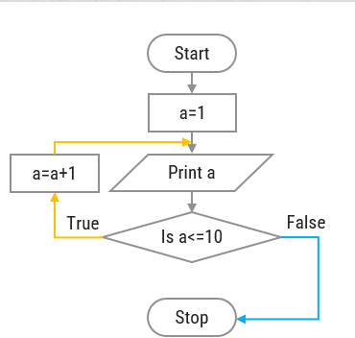

Example 6: Prime Number Check
[Flowchart Execution Steps]
1. Start Read N.
2. Initialize I = 2, count = 0.
3. Check Loop: If I <= N - 1:
• If N % I == 0: count = count + 1.
• Increment I = I + 1. Loop back.
4. Final Evaluation: If count == 0:
• True: Print 'Prime'.
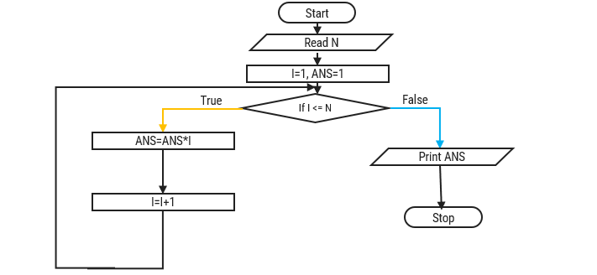
• False: Print 'Not Prime'.
5. Stop.

Example 7: Factorial Calculation
[Flowchart Execution Steps]
1. Start Read N.
2. Initialize I = 1, ANS = 1.
3. Condition Check: If I <= N:
• True: Calculate ANS = ANS * I.
• Increment I = I + 1.
• Loop back to condition check.
4. False: Print ANS.
5. Stop.

6. Interactive In-Class Exercises & TA Prompts
Spot-The-Bug Challenge (Board Activity)
Draw a broken loop flowchart on the board where a = a + 1 is omitted in the counter loop, or where a decision diamond has no True/False labels. Ask students:
"What happens when a computer tries to execute this flowchart?"
Goal: Teach students that missing loop increments lead to infinite loops in C (while(1) freeze).

Discussion Question for Students
Question: "Why do we start checking prime numbers from I = 2 up to N - 1 instead of starting from I = 1?"
Expected Answer: Every integer is divisible by 1, so starting from 1 would always increment count and make every number appear non-prime!

Summary Checklist
Checklist Items
- Ensure all students know the 5 basic flowchart shapes and their C syntax equivalents.
- Remind students that decision diamonds MUST have two outgoing branches labeled True/False or Yes/No.
- Verify that students always draw explicit arrowheads to indicate execution flow.
- Connect algorithms directly to upcoming C concepts: if-else (Decision), for/while (Looping), and scanf/printf (I/O).

